Case Report:
Non rigid connectors-a management of pier abutment – a case report
Dr. Rupal J. Shah, Dr. Sanjay Lagdive, Dr. Vishal Kothari, Dr. Dharmendra Sindha, Dr. Kiran Hadiya

Dept of Prosthodontics, Govt Dental College and Hospital, Ahmadabad
Corresponding author: Dr. Vishal Kothari
Abstract:
In Prosthetic dentistry, teeth supported fixed dental prosthesis is one of the common treatment modalities in which occlusal forces are directly transmitted to the periodontium through the components of fixed dental prosthesis namely retainer, pontic and connectors Connectors are the components of partial fixed prosthesis or splint that join the individual retainers and pontics together. Usually, this is accomplished with rigid connectors.Connector is the maximum stress bearer component of fixed partial denture. Longevity of fixed partial denture and abutment rely on occlusion, span length, bone loss, quality of periodontium. Overload , leverage, torque and flexing are biomechanical factors which generate aberrant stress concentration.

Introduction
In Prosthetic dentistry, teeth supported fixed dental prosthesis is one of the common treatment modalities in which occlusal forces are directly transmitted to the periodontium through the components of fixed dental prosthesis namely retainer, pontic and connectors Connectors are the components of partial fixed prosthesis or splint that join the individual retainers and pontics together. Usually, this is accomplished with rigid connectors.Connector is the maximum stress bearer component of fixed partial denture. Longevity of fixed partial denture and abutment rely on occlusion, span length, bone loss, quality of periodontium. Overload , leverage, torque and flexing are biomechanical factors which generate aberrant stress concentration.⁽¹⁾
In some patients, the pattern of missing teeth may require the use of an FDP with a pier abutment. Pier abutment also known as an intermediate abutment is

defined as a natural tooth located between terminal abutments that to support a fixed or removable dental ^{prosthesis(2)}. Restoration of two missing teeth and an intermediate pier abutment with a rigid FDP is not an ideal ^{treatment(3-5).} When an occlusal load is applied to the retainer on the abutment tooth at 1 end of an FDP with a pier abutment, thepier abutment may act as a fulcrum.Thus, tensile forces maythen be generated between the retainer and abutment at the other endof the restoration⁽⁶⁾.
According to Savion et al, the possible cause for debonding is development of extrusive reactive forces at the proximal retainer as the distal abutment is loaded due to flexural forces developed within the ^{FDP(7)}. Thus, these type of restorations may result in marginal leakage and caries⁸. In the mandibular, FDP consisting of anterior and posterior segments, a non rigid connector is indicated as themandible flexes mediolaterally during opening and closing strokes. Furthermore, the excessive flexing of a long-span FDP varies with the cube of the length of the edentulous span, which can lead to material failure of the prosthesis or an unfavorable ^{response(9)}.
Anterior or posteriorabutments may experience extrusiveforces during fulcrum action, andresultant tensile force at the retainerto-abutment interface may result inpotential loss of retention for theserestorations. It has been reportedthat rigid FDPs with pier abutmentsare associated with higher debondingrates than short-span prostheses. Thus, these restorations may result inmarginal leakage and caries.⁽⁶⁾
Non-rigid connectors convey loads to supporting bone rather than concentrating it in the connectors. It allows two part of the fixed partial denture to move independently, by which mesio-distal torquing of abutments is minimized.The location of the non-rigid connector in this type of pier abutment cases is very important.It usually is placed on the middle abutment, since placement of it on either of the terminal abutments could result in the pontic acting as a lever arm. The keyway of the should be placed within the normal distal contours of the pier abutment, and the key should be placed on the mesial side of the distalpontic.^{(9,10)Shillinberg(11)} suggested placing the connectors at the distal aspect of pier abutment.Since the long axis of the posterior teeth usually leans slightly in a mesial direction, vertically applied occlusal forces produce further movement in this direction.This would nullify the fulcrum effect and the patrix/male of the attachment would be seated firmly in place when pressure is applied distally to the pier.This position has been supported by finite element analysis stydy by Oruc et ^{al(6)}

Four types of non-rigid connectors are the ⁽¹²⁾
- Dove tail key-key way or Tenon-Mortise type connector
- Cross pin and wing type connector
- Split type
- Loop type
Case report-
A 50 year old male patient reported to the department of prosthodontics, Government dental college and hospital, Ahmedabad, with the chief complain of difficulty in chewing and poor esthetics due to missing teeth on upper left side. On examination, maxillary left 1st premolar and 1st molar was missingwith canine and 2nd molar acting as a terminal abutment and 2nd premolar acting as pier abutment. Intra oral periapical radiograph showed good bone support for all the teeth to be used as abutments.
Available treatment options were as follows:
a. Implant in edentulous spaces.
b. Fixed partial denture with rigid connector.
c. Fixed partial denture with non-rigid connector.

Treatment involving implant placement was not opted due to economic constraint. The treatment of the patient with Fixed Partial Denture with rigid connector would have resulted in deleterious effect on abutments as well as the final prosthesis Thus, the custommade tenon-mortise semi precision was planned. Tooth preparation of 23, 25, and 27 wasmodified following the biomechanical principles of tooth preparation.
Clinical procedure:
1. The tooth preparation of canine, second premolar was done for metal-ceramic fixed partial denture and non-rigid connector between the second premolar and first molar and for molar it was modified for metal fixed partial denture for 1st and 2nd molar bcause of economic factor and due to decreased crown height of 2nd molar . The distal of the second premolar was prepared to accommodate a non-rigid connector.
2. Two step putty wash impression was made for the preparation of the working model. It was poured in high-strength type IV dental stone.
3. Provisional restoration was cemented.
4. Fixed partial denture with non-rigid connector was prepared. First, the anterior segment of canine, first premolar and second premolar withthe keyway (Mortise) on its distal aspect was fabricated. Then the second and the first molars with key (Tenon) on its mesial aspect was fabricated in wax and then cast.
5.With the dental surveyor , Accurate alignment of keyway parallel to path of placement of distal retainer was accomplished.
6. After casting, metal try-in of the individual units were done to verify proper seating. Then ceramic layer was added.
7. Cementationwas done with glass ionomer cement, mesial segment was placed first followed by cementation of distal segment .
Discussion
The size, shape and type of connector play a significant job in the success of a fixed dental ^{prosthesis(13)}. It has been proved that high stress values are found at the connectors and cervical regions of abutment teeth,particularly at the pier abutment. When a rigidly designed fixed dental prosthesis with a pier abutment acts as a lever, excessive displacements may be observed at terminal abutments, resulting in damage to the abutment teeth or debonding of the weak retainer. The conventional use of non rigid connector aids in compensating the difference in resistance and retention form between the abutments. The design and passive fit of Non-rigid connector is critical.⁽¹⁴⁾When a Non-rigid connector is integrated at distal region of the pier abutment, the area of stressconcentration in pier abutment is reduced.^{(6,15)}Botehlo and Dyson reported that rigid FPDs withpier abutment are linked with higher debonding rates than short span prosthesis.⁽¹⁶⁾
There is a conflicting opinion on where to place the non-rigid connector. However, ^{Markley(14)} suggested that non-rigid connector should be placed at one of the terminal retainer, and emphasized that it should not be placed at the pier abutment because this would subject the relatively weak premolar abutment to extreme loads. ^{Adams(17)} suggested placing the connector at the distal side of pier, and if desired, adding one more at the distal side of the anterior retainer, while Gill¹⁸ suggested placing it at one side or both sides of the pier. Carl E.^{Misch(19)} recommended that in conventional fixed prostheses, the "male" portion of a nonrigid attachment usually is located on the mesial aspect of the posterior pontic, whereas the "female" portion is in the distal aspect of the natural pier abutment tooth. This prevents mesial drift from unseating the attachment. However, an implant does not undergo mesial drifting, and the nonrigid connector location is more flexible. For a natural pier abutment between two implants, a stress breaker is not indicated.
In this case report, the nonrigid connector was placed on the distal side of the pier abutment which was beneficial. Since the long axis of the posterior teeth usually leans slightly in a mesial direction, vertically applied occlusal forces produce further movement in this direction. This would nullify the fulcrum effect and the patrix/male of the attachment would be seated firmly in place when pressure is applied distally to the pier.
Advantages of non rigid connectors are they, transmit shear stresses to supporting bone rather than concentring them in connectors. It minimizes mesiodistal torquing of abutments and allow them to
move ^{independently(20)}.
Disadvantage of non rigid connectors are:
(1) More tooth reduction of pier abutment,
(2) Increased laboratorytime and expense.
(3) In the absence of occlusal stability some, keyhave been observed to lift off from their keyway (²¹⁾.
Conclusion
As connector in fixed dental prosthesis plays important role in masticatory force distribution, the selection of connector is important step in treatment planning of FDP. Non-rigid connector act as stress breaker to abutments and allowing physiologic tooth movements. So the architecture and passivity of non-rigid connectors are revealing to outcome of long span fixed dental prosthesis.

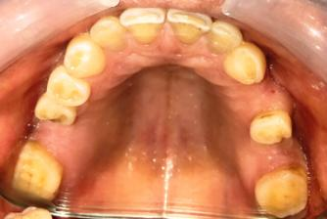
Figure1 Pre-Operative Photograph
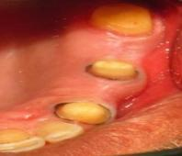

Figure 2 Prepared abutments and gingival retraction

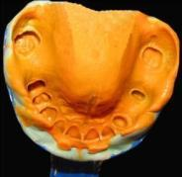
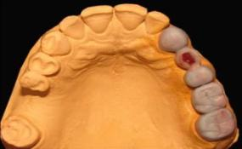
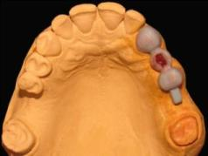

Figure 5 Completed wax pattern with tenon in distal segment segment
Figure 4Wax pattwern of Mesial segment with motise distal to pier abutment
figure 3 Final Impression

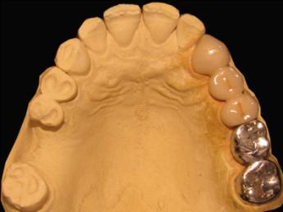
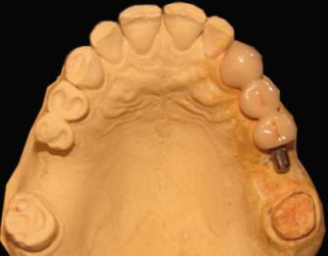
Fig.6 After casting and ceramic layering mesial segment with mortise
Fig.7 Final prosthesis with tenon on distal segment

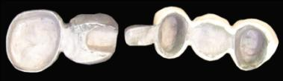
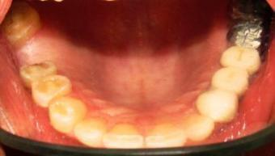

Fig8 Close-up view of prosthesis with tenon-mortise
Fig.9 Cemented final prosthesis

References
1) SP Dange , AN Khalikar , Shiv Kumar. Non-rigid Connectors in Fixed Dental Prosthesis - ACase Report , JIDANov 2008;2(11):356
2)Glossary of the Prosthodontics terms. 8th edition. J Posthet Dent. 2005; 94:11-95.
3)Ziada HM, Barrett BE. Case report: a nonrigidconnector for a resin bonded bridge.Eur J Prosthodont Restor Dent 2000;8:67-9.
4) Shillingburg HT Jr, Hobo S, Whitsett LD, JacobiR, Brackett SE. Fundamentals of fixed
prosthodontics. 3rd ed. Chicago: Quintessence;1997. p. 85-118.
5) Ziada HM, Orr JF, Benington IC. Photoelasticstress analysis in a pier retainer of ananterior resin-bonded fixed partial denture.J Prosthet Dent 1998;80:661-5.
6)Oruc S, Eraslan O, Tukay HA, Atay A. Stress analysis of effect of non-rigid connectors on fixed partial dentures with pier abutments.J Prosthet Dent2008;99:185-92
7) Savion I, Saucier C, Rues S, Sadan A, BlatzM. The pier abutment: Review ofliterature and a suggested mathematicalmodel. Quintessance Int 2006; 37:345-52.
8) Rosenstiel SF, Land MF, Fujimoto J (2006)Contemporary fixed prosthodontics 4thedition.Pg 673-93.
9) Shillingburg HT Jr, Fisher DW (1973)Nonrigid connectors for fixed partialdentures. J Am Dent Assoc 87: 1195-99.
10) Prince Kumar, Vishal Singh1, RoshniGoel2, Harkanwal P Singh.Non‑rigidconnector in fixed partial dentures withpier abutment: An enigma simplified. Int JHealth & Allied Sci 2012; 1:190-3.
11)Shillinberg HT Jr., Hobo S, Whitsett LD, Jacobi R, Brackett SE. Fundamentals of fixed prosthodontics.3rd ed. Chicago: Quintessence; 1997. P. 85-118
12)Chaturvedi S, verma AK vadhvani P. Non –rigid connector: relay the stress. Ind JDent Sci. 2012; 4:53-5.
13) Tylman’s theory of fixed Prosthodontics;. St. Louis; 1989;8: 74 -5.
14) Markley MK. Broken-stress principle anddesign in fixed bridge prosthesis. JProsthet Dent 1951; 1: 416-23.
15)Kathuria N, Prasad R, Bhide SV , Gulati M, Gupta N. Effect of Non Rigid Connectoron FPD with Pier Abutment: A CaseReport. J Clinic Case Reports 2012; 2: 68-70.
16) Botelho MG, Dyson JE. Long-span, fixedmovable,resin-bonded fixed partial
dentures: a retrospective, preliminaryclinical investigation. Int J Prosthodont2005; 18: 371-6.
17) Adams JD .J Am Dent Assoc. Planning posterior bridges. 1956;53:647- 54.
18) Gill JR. Treatment planning for mouth rehabilitation. J Prosthet Dent. 1952;2:230-45.
19) Carl E.Misch Dental implant prosthetics. Elsevier Mosby. 2005; Pg:189-190.
20)Sutherland JK, Holland GA, Siuder TB, White JT. A photo elastic analysis of thestress distribution in bone supporting fixed partial denture of rigid and non rigiddesign. J Prosthet Dent. 1980; 44: 616-23.
21)Shillinburg HT jr, Sather DA, Wilson EL, Cain JR, Mitchell DL, Blanco LJ, et al.Fundamental of fixed Prosthodontics. Chicago: Quintessence; 2012;4:91-2.

